**HOW TO MAKE A BROCHURE IN PHOTOPSHOP**

**Step 1: Open Photoshop.**

**Step 2: Choose brochure template from photoshop templates.**

**Step 3: Create a background layer.**

**Step 4: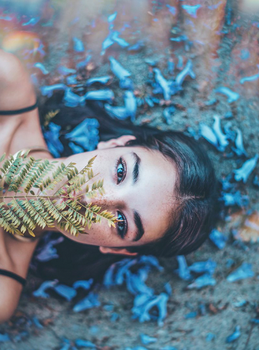 Import a background image or create your own image from pc.**

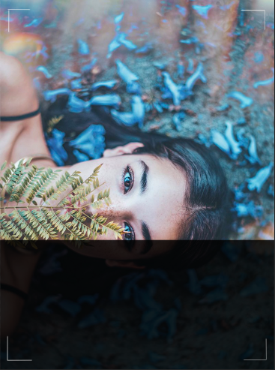**Step 5: Draw borders using the brush tool or the shape tool.**

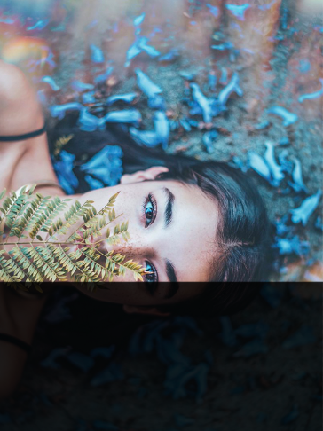

**Step 6: Create a text layer clicking on the T icon.**

**Step 7: Type the text you want in the brochure.**

**Step 8: Choose appropriate fonts and colours.**

**Step 9: Align the text.**

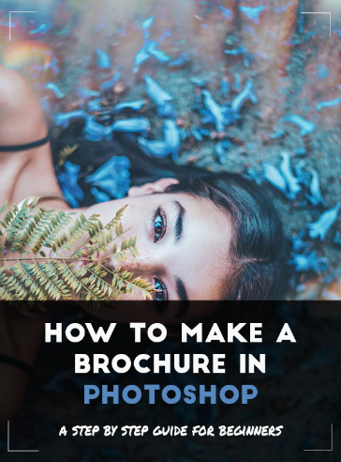

**Step 10: Import logos and pictures. Place them appropriately on the brochure.**

**Step 11: GO to file and then quick export as PNG and save the brochure at a location on your computer**

